# **SUPPLEMENTARY INFORMATION**

# **SUPPLEMENTARY NOTES**

**Contents**

Genomic Structural Equation Modelling ................................................................................... 3

Processing of summary statistics ............................................................................................3

Common factor model ............................................................................................................4

Effective sample size calculation ...........................................................................................4

GWAS-by-subtraction ...............................................................................................................4

Effective sample size calculation ...........................................................................................5

Novel genetic variants associated with psychiatric disorders beyond transdiagnostic effects for BIP, ADHD, AN and ALCH………………………………………………………………5

Gene, gene-set, tissue property and brain development stage enrichment results for BIP, ADHD, AN and ALCH..............................................................................................................6

Supplementary References ......................................................................................................32

# **SUPPLEMENTARY FIGURES**

**Contents**

Supplementary Figure 1. Manhattan plot of the pGWAS .....................................................8

Supplementary Figure 2. Manhattan plot of the MDD Non-pGWAS ...................................9

Supplementary Figure 3. Manhattan plot of the ANX Non-pGWAS ...................................10

Supplementary Figure 4. Manhattan plot of the PTSD Non-pGWAS ..................................11

Supplementary Figure 5. Manhattan plot of the ALCH Non-pGWAS .................................12

Supplementary Figure 6. Manhattan plot of the ASD Non-pGWAS ....................................13

Supplementary Figure 7. Manhattan plot of the OCD Non-pGWAS ................................... 14

Supplementary Figure 8. Manhattan plot of the AN Non-pGWAS ..................................... 15

Supplementary Figure 9. Manhattan plot of the TS Non-pGWAS .......................................16

Supplementary Figure 10. The tissue type enrichment results on 53 specific tissue types by GTEx of Schizophrenia uncorrected and corrected for p .......................................................17

Supplementary Figure 11. The brain sample enrichment results on 11 general brain developmental stages by BrainSpan of Schizophrenia uncorrected and corrected for……...18

Supplementary Figure 12. The tissue type enrichment results on 53 specific tissue types by GTEx of Bipolar uncorrected and corrected for p....................................................................19

Supplementary Figure 13. The brain sample enrichment results on 11 general brain developmental stages by BrainSpain of Bipolar uncorrected and corrected for p…...............20

Supplementary Figure 14. The tissue type enrichment results on 53 specific tissue types by GTEx of ADHD uncorrected and corrected for p....................................................................21

Supplementary Figure 15. The brain sample enrichment results on 11 general brain developmental stages by BrainSpan of ADHD uncorrected and corrected for p……………22

Supplementary Figure 16. The tissue type enrichment results on 53 specific tissue types by GTEx of AN uncorrected and corrected for p……………………………………………….23

Supplementary Figure 17. The brain sample enrichment results on 11 general brain developmental stages by BrainSpan of AN uncorrected and corrected for p……………….24

Supplementary Figure 18. The tissue type enrichment results on 53 specific tissue types by GTEx of ALCH uncorrected and corrected for p ...................................................................25

Supplementary Figure 19. The brain sample enrichment results on 11 general brain developmental stages by BrainSpan of ALCH uncorrected and corrected for p……………26

Supplementary Figure 20. Genetic correlations between the psychiatric disorders and health-related traits before and after controlling for p .......................................................................27

Supplementary Figure 21. Genetic correlations between the psychiatric disorders and anthropometric traits before and after controlling for p ..........................................................28

Supplementary Figure 22. Genetic correlations between psychiatric disorders and socio-demographic traits before and after controlling for p ............................................................29

Supplementary Figure 23. Sensitivity analysis- common factor model in Genomic SEM.........................................................................................................................................30

Supplementary Figure 24. Genetic correlations between psychiatric disorders after correcting for p from sensitivity analysis results .....................................................................................31

# **SUPPLEMENTARY NOTE**

**Genomic Structural Equation Modelling**

Genomic structural equation modelling (Genomic SEM 1) is a framework that applies structural equation modelling to GWAS summary statistics to model patterns of genetic correlations between complex traits. Here, we used Genomic SEM to create a genomic p factor from the summary statistics of 11 major psychiatric disorders.

Genomic SEM uses a two-stage estimation process 1. In the first stage, the genetic covariance matrix and associated sampling covariance matrix are estimated. In the second stage, a model is specified, and parameters are estimated by attempting to minimize the discrepancy between the model-implied genetic covariance matrix and the empirical covariance matrix. The fit of the model can then be evaluated using standard goodness-of-fit indices, including standardized root mean square residual (SRMR), model *χ*2, Akaike Information Criterion (ACI) and the Comparative Fit Index (CFI).

**Processing of summary statistics**

We processed GWAS summary statistics for use in Genomic SEM as follows. Summary statistics were formatted with the *munge* function within Genomic SEM R package v.0.0.5 (using default parameters). The *munge* function converts the summary statistics to the format expected by LDSC by removing all the SNPs that are not present in the reference panel, and, when the information is available, filtering out SNPs with minor allele frequency < 1% and information score < 0.9. The HapMap3 reference file is provided in the Genomic SEM repository (<https://github.com/GenomicSEM/GenomicSEM>). The processed summary statistics were then used in a multivariable version of LDSC implemented in Genomic SEM to estimate the genetic covariance and sampling covariance matrices for the 11 disorders i.e., SCZ, BIP, ADHD, MDD, ANX, PTSD, ALCH, ASD, OCD, AN, TS. The genetic covariance matrix contains SNP-based heritability estimates on the diagonal and genetic covariance on the off-diagonal. The sampling covariance matrix contains squared standard errors on the diagonal (the sampling variances) and sampling covariances on the off-diagonal, which index sampling dependencies that will arise when there is participant sample overlap. The LD weights used for LDSC were calculated using the European subsample of the 1000 Genome Phase 3 project, excluding the major histocompatibility complex due to complex LD structures in this region that can bias estimates.

The *sumstats* function within Genomic SEM was then used to standardize all SNPs. In this step, summary statistics for each of the 11 disorders were restricted to SNPs with minor allele frequency > 1% and information score > 0.6, and to SNPs that were present for all of the 11 disorders. The summary statistics were also filtered to SNPs present in the European-only 1000 Genomes Phase 3 reference panel. After these quality control steps, 3,746,806 SNPs were present across all 11 disorders.

Before running the model, the genetic covariance and sampling covariance matrices were transformed into genetic correlation and sampling correlation matrices. These standardized LDSC matrices were then used as input into the model specified within Genomic SEM.

**Common factor model**

To capture transdiagnostic genetic effects across all 11 disorders, we fitted a common factor model to the genetic covariance matrix produced in Genomic SEM. In this model, all disorders loaded on a single common factor. Model fit was assessed using standard indices used in structural equation modelling, including standardized root mean square residual (SRMR), model *χ*2, Akaike Information Criterion (ACI) and the Comparative Fit Index (CFI). The model provided adequate fit, (χ2(44) = 950.4836, AIC = 994.48, CFI = .82, SRMR = .12).

**Effective sample size calculation**

We calculated effective sample sizes for each of the 11 disorders following the method described by Grotzinger et al. (2023) 2. According to this method, the effective sample size for GWAS that was meta-analysed was calculated by summing the effective sample sizes across contributing cohorts. This approach incorporates cohort-specific ascertainment, which provided an unbiased estimate of liability scale heritability for binary traits. We refer the reader to Grotzinger et al. (2023) 2 for a detailed explanation of why this method produces a more accurate estimate of heritability for binary traits.

**GWAS-by-subtraction**

GWAS-by-subtraction 3 is a specific model within Genomic SEM that that estimates, for each SNP, an effect on a specific trait that is independent of that SNP’s effect on another trait. Using schizophrenia as an example, the GWAS summary statistics for p factor and SCZ are regressed on a latent factor, ‘p SCZ’, which represents genetic variance that is shared across the 11 disorders (Figure S1, left). SCZ was further regressed on a second latent factor representing the residual genetic variance in SCZ left over after regressing out variance related to p, i.e., non-p SCZ (Figure S1, right). By construction, the genetic variance in non-p SCZ is independent of genetic variance in the p-factor (*r*g = 0). In other words, the non-p SCZ factor represents genetic variance in SCZ that is not accounted for by the p-factor. The two latent variables, p-SCZ and non-p SCZ are then regressed on each SNP, iterating across all SNPs in the GWAS, resulting in new GWAS summary statistics for non-p SCZ.

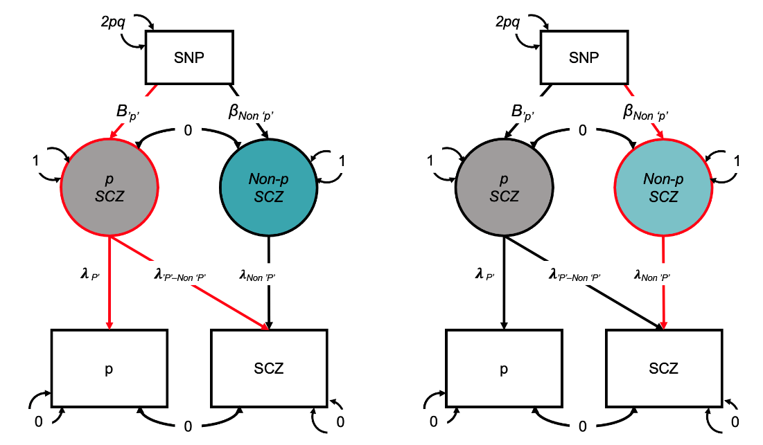

**Figure S1.** Schematic overview of the GWAS-by-subtraction approach for creating a latent residual for the schizophrenia (SCZ)-specific factor (Figure adapted from Demange et al., 2021 3). In this diagram, squares represent the observed SNP and the GWAS of p-factor and SCZ. Circles represent the latent (unobserved) variables, i.e., P SCZ and Non-p SCZ. Single-headed arrows represent linear regression associations pointing from the independent variable to the dependent variable. Two-headed arrows represent covariance relationships. The covariances between p-factor and SCZ and between p SCZ and Non-p SCZ are fixed to 0. The variance of the SNP is fixed to the value of 2pq (p= reference allele frequency, q= alternative allele frequency, based on 1000 Genomes Project phase 3). The residual variances of p and SCZ are fixed to 0, so that all variance is explained by the latent factors. The variances of the latent factors are fixed to 1. λ= freely estimated factor loadings that are equivalent to regression weights. Β= regression effects of p SCZ and Non-p SCZ on the SNP.

**Effective sample size calculation for latent residual factors**

We calculated the expected sample size of the latent non-p factors following the method described by Demange et al. (2021) 3. According to this method, effective sample sizes, estimated based on the formula described by Mallard et al. (2022) 4, are adjusted by multiplying them by the residual heritability (squared unstandardized path loading).

**Novel genetic variants associated with psychiatric disorders beyond transdiagnostic effects for SCZ, BIP, ADHD, AN and ALCH**

After removing the transdiagnostic genetic effects associated with p, 5 out of 11 psychiatric disorders revealed GWA significant hits in the Non-p GWASs, namely Schizophrenia (SCZ), Bipolar Disorder (BIP), ADHD, Alcohol Use Disorder (ALCH), and Anorexia Nervosa (AN). Among these disorders, except for ALCH, all showed novel SNPs associated. These newly detected SNP associations are presented in Supplementary Tables 4-8. The top significant novel SNPs for each disorder are rs693906 for SCZ, rs12234369 for BIP, rs797419 for ADHD, and rs9877794 for AN. The findings for SCZ are reported in the main manuscript.

**BIP**

In total, 9 SNPs out of the 19 independent SNPs associated with BIP after removing transdiagnostic effects were novel SNP associations. Of the 9 novel SNPs, five were completely novel (have not been reported in any published GWASs), two were associated with physiological traits including placental abruption 5 and eosinophil count 6, one was associated with cortical surface area in BIP population 7 and one, the top significant novel SNP for BIP (rs12234369), was previously found to be associated with educational attainment 8,9 and neuroticism 8. The full list of novel SNPs and independent hits for the BIP GWAS after accounting for p is presented in Supplementary Table 5.

**ADHD**

Out of the 11 independent SNPs that were found to be significantly associated with ADHD after controlling for transdiagnostic effects, 4 were novel associations. One SNP was found to be associated with depression 10, one was found to be associated with the synaptic organization of ADHD 7, and 2 SNPs were novel associations that had not been previously reported, including the top novel SNP, rs797419. The full list of the novel SNPs and independent hits for ADHD after removing transdiagnostic effects is reported in Supplementary Table 6.

**AN**

Out of the 6 independent hits that emerged for AN after accounting for transdiagnostic effects, 5 were novel SNP associations. All novel variants were located on Chromosome 3. Three SNPs had been previously identified in a Transcriptome Wide Association study of AN 11, a study looking at genetic associations across TS and ADHD 12, and a GWAS study of skeletal muscle 13. Two SNPs were completed novel, including the most significant novel SNP rs9877794. The full list of the novel SNP and independent hits of AN are in Supplementary Table 7.

**ALCH**

None of the two independent significant SNPs associated with ALCH after accounting for transdiagnostic effects were novel. Independent hits associated with ALCH are reported in Supplementary Table 8.

**Gene, gene-set, tissue property and brain development stage enrichment results for BIP, ADHD, AN and ALCH**

Gene, gene-set, tissue property and brain development stage enrichment analysis were performed for the 5 GWAS that uncovered genome-wide significant hits beyond transdiagnostic effects (i.e. SCZ, BIP, ADHD, AN, ALCH). The analyses were performed using MAGMA in FUMA. The method is briefly described in the main manuscript and additional details can be found in Watanabe et al. (2017)14 and Watanabe et al (2019) 15. The results for SCZ are presented in the main text while those for BIP, ADHD, AN and ALCH are reported below. All results reported are Bonferroni's corrected (p = 0.05/18771 = 2.664e-6) to reduce multiple comparison problems.

**BIP**

After controlling for transdiagnostic effects, there were 72 genes associated with BIP (see Supplementary Table 11). The most significantly associated gene was KCNS1. Five gene sets were enriched in BIP non-p, all related to synaptic signalling. The full list of the enriched gene sets and their associated genes is reported in Supplementary Table 12. The signal was only enriched among genes expressed in different brain tissues (Supplementary Figure 12, Supplementary Table 22), if compared to the signal across other tissue types. The cortex was the most enriched brain region. The only enriched brain development stage changed from young adulthood to late infancy as showed in Supplementary Figure 13 and Supplementary Table 23 and 25.

**ADHD**

After accounting for transdiagnostic effects, 22 genes were associated with the ADHD genetic signal (full list presented in Supplementary Table 13), The gene showing the most significant link with ADHD non-p was CDH8. No gene sets were enriched for ADHD after accounting for transdiagnostic effects. The tissue property enrichment analyses in MAGMA showed that five brain regions were enriched, with the frontal cortex showing the strongest signal (Supplementary Figure 14 and Supplementary Table 26). None of the brain developmental stages showed significant enrichment (Supplementary Figure 15 and Supplementary Table 27).

**AN**

The genetic signal associated with AN after removing transdiagnostic effects was enriched in 38 genes (Supplementary Table 14), with the most significant association found for NCKIPSD. The gene NCKIPSD had been previously found to be enriched in AN 16 as well as several metabolic, anthropometric and psychological phenotypes (e.g. waist circumference 17; BMI 18; Cognitive abilities 9,19). Gene set analyses did not show significant enrichment, while tissue enrichment analyses in MAGMA showed enrichment in two brain tissue types: cerebellum and cerebellar hemisphere (Supplementary Figure 16 and Supplementary Table 30). None of the brain developmental stages showed significant enrichment (Supplementary Figure 17 and Supplementary Table 31).

**ALCH**

Only one gene, KLB, showed a significant association with ALCH after accounting for transdiagnostic effects (Supplementary Table 15). KLB was found to have a protective effect against excessive alcohol intake in animal studies 2020. Gene set, tissue type and brain development stages enrichment analysis did not reveal any significant associations (Supplementary Figure 18-19, Supplementary Table 34-35).

# **SUPPLEMENTARY FIGURES**

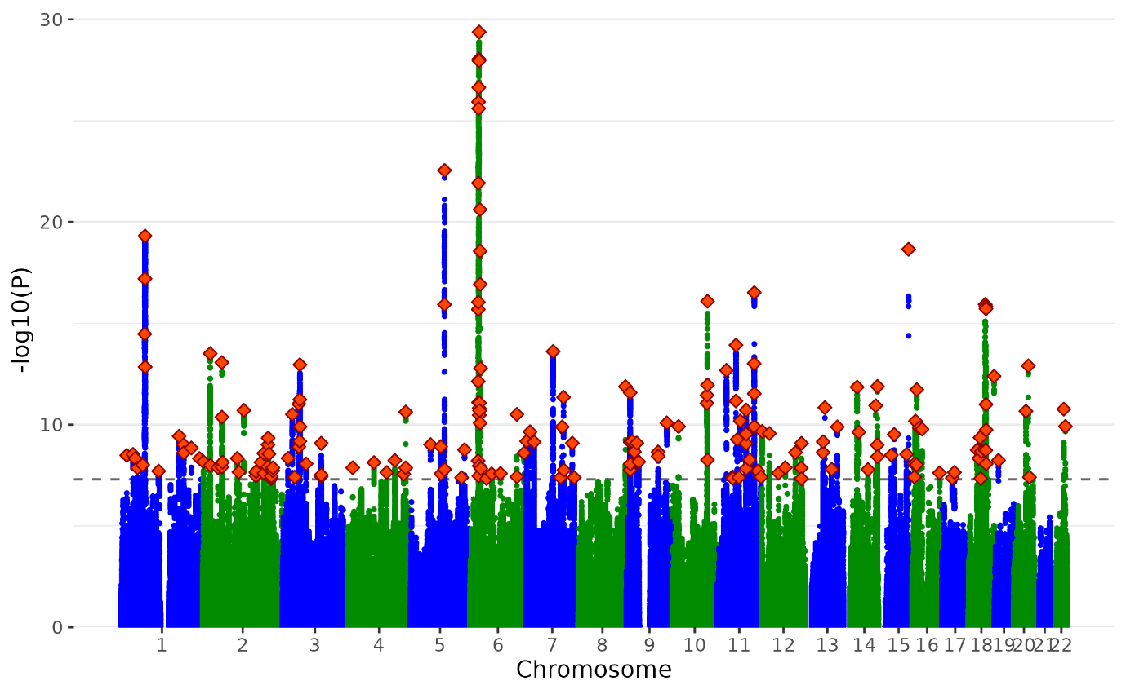

**Supplementary Figure 1. Manhattan plot of the pGWAS.** Plot of the -log10(p-value) associated with the Wald test (two-sided) of βp for all SNPs ordered by chromosome and base position. Red diamonds indicate genome-wide significant independent hits (within a 250Kb window and r2 < .1) associations. We identified 200 independent genome-wide significant lead SNPs for p GWA S

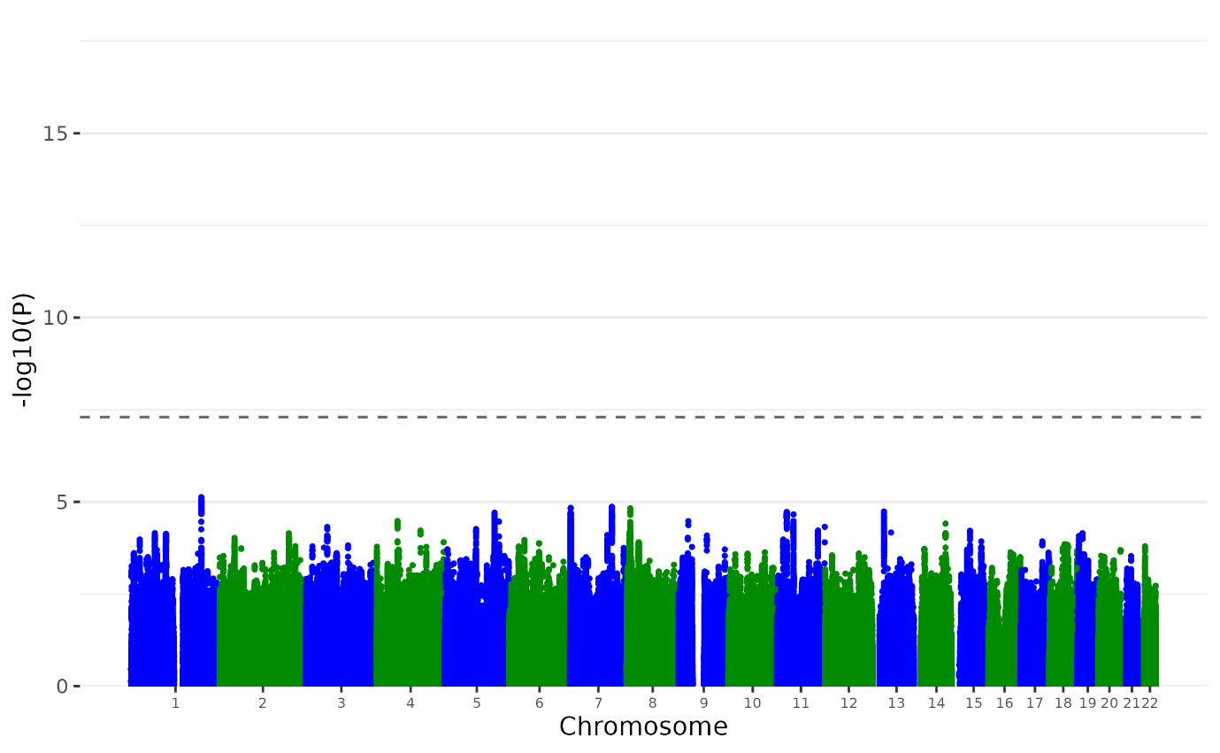

**Supplementary Figure 2. Manhattan plot of the MDD Non-p GWAS.** Plot of the -log10(p-value) associated with the Wald test (two-sided) of βp for all SNPs ordered by chromosome and base position. Red diamonds indicate genome-wide significant independent hits (within a 250Kb window and r2 < .1) associations.

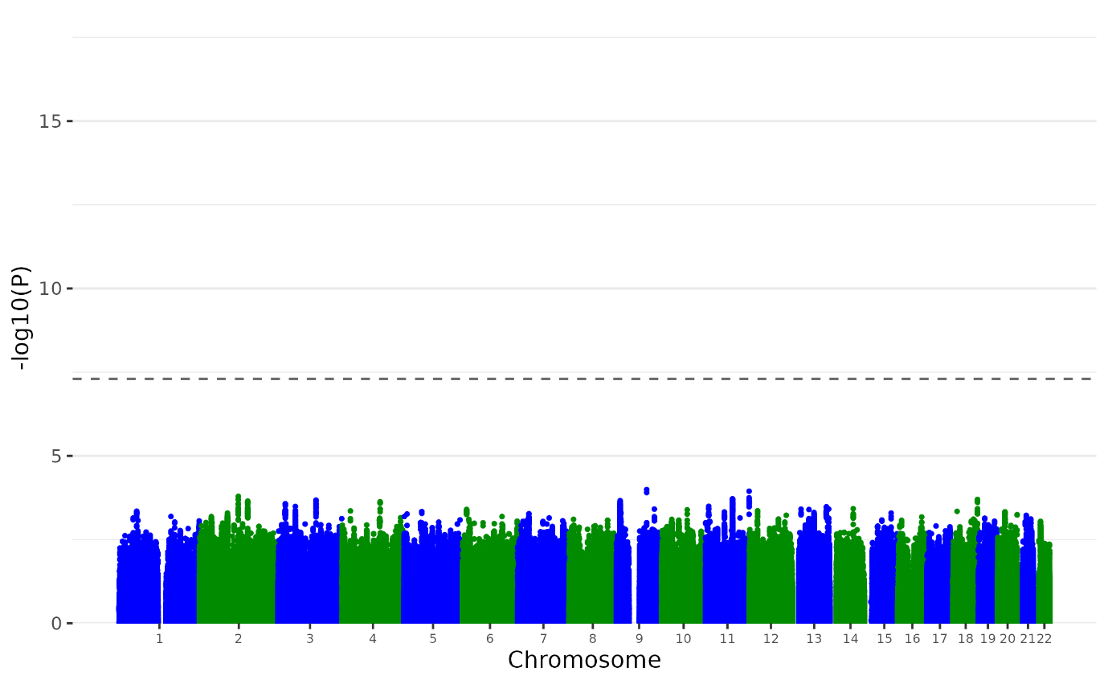

**Supplementary Figure 3. Manhattan plot of the ANX Non-p GWAS.** Plot of the -log10(p-value) associated with the Wald test (two-sided) of βp for all SNPs ordered by chromosome and base position. Red diamonds indicate genome-wide significant independent hits (within a 250Kb window and r2 < .1) associations.

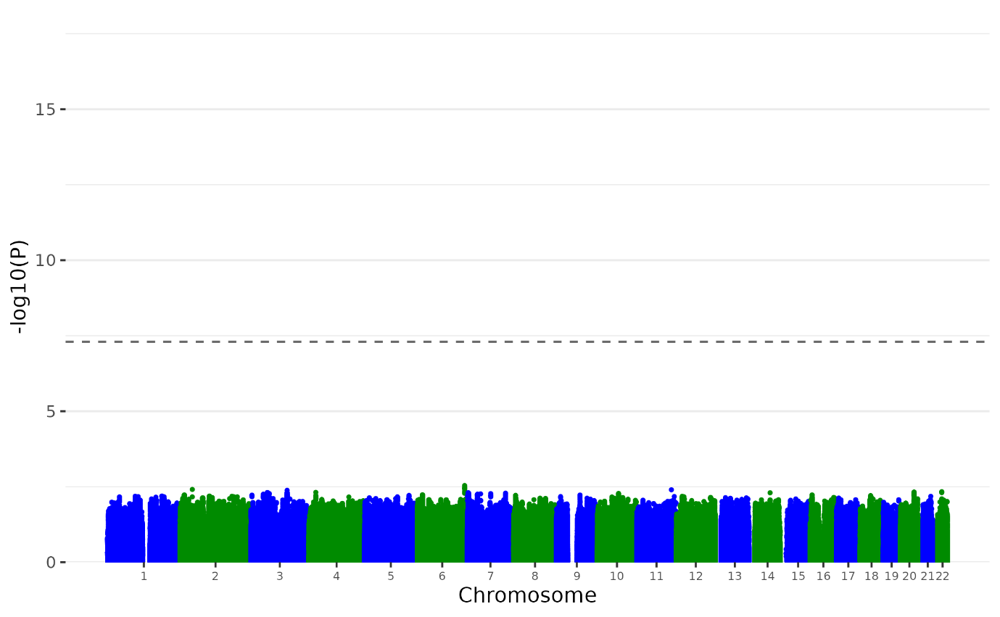

**Supplementary Figure 4. Manhattan plot of the PTSD Non-p GWAS.** Plot of the -log10(p-value) associated with the Wald test (two-sided) of βp for all SNPs ordered by chromosome and base position. Red diamonds indicate genome-wide significant independent hits (within a 250Kb window and r2 < .1) associations.

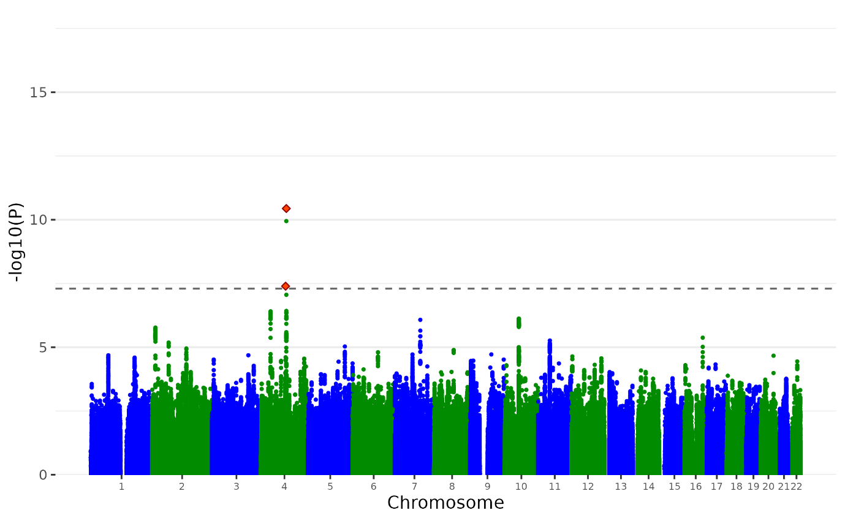

**Supplementary Figure 5. Manhattan plot of the ALCH Non-p GWAS.** Plot of the -log10(p-value) associated with the Wald test (two-sided) of βp for all SNPs ordered by chromosome and base position. Red diamonds indicate genome-wide significant independent hits (within a 250Kb window and r2 < .1) associations. We identified 2 independent genome-wide significant lead SNPs for ALCH Non-p GWAS.

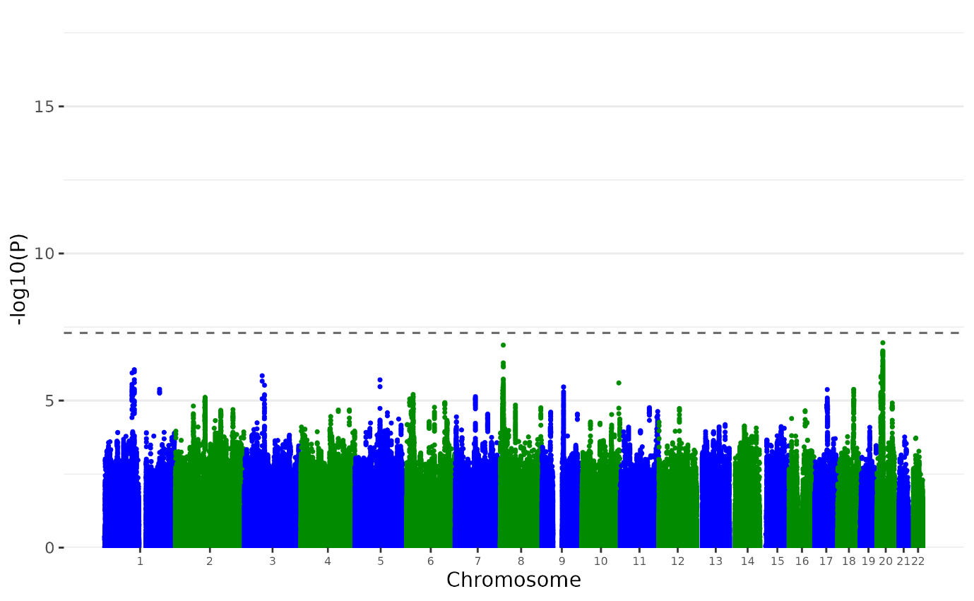

**Supplementary Figure 6. Manhattan plot of the ASD Non-p GWAS.** Plot of the -log10(p-value) associated with the Wald test (two-sided) of βp for all SNPs ordered by chromosome and base position. Red diamonds indicate genome-wide significant independent hits (within a 250Kb window and r2 < .1) associations.

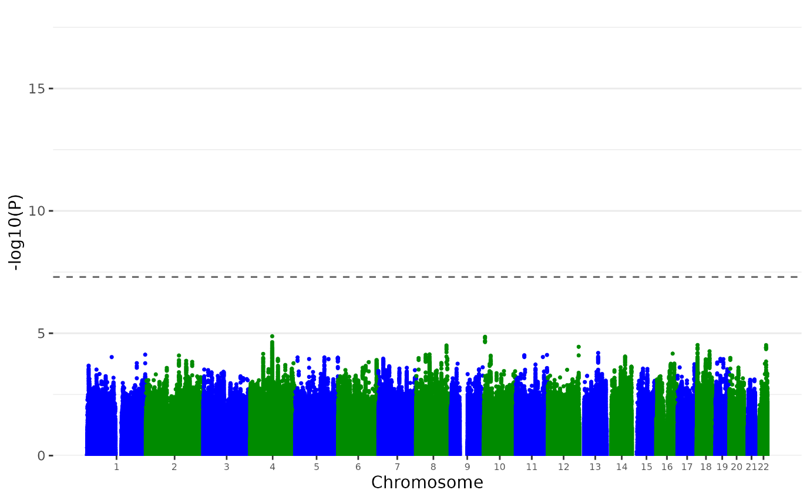

**Supplementary Figure 7. Manhattan plot of the OCD Non-p GWAS.** Plot of the -log10(p-value) associated with the Wald test (two-sided) of βp for all SNPs ordered by chromosome and base position. Red diamonds indicate genome-wide significant independent hits (within a 250Kb window and r2 < .1) associations.

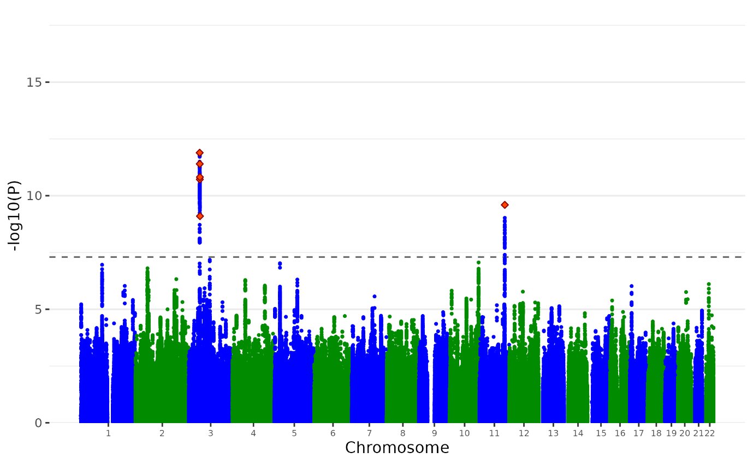

**Supplementary Figure 8. Manhattan plot of the AN Non-p GWAS.** Plot of the -log10(p-value) associated with the Wald test (two-sided) of βp for all SNPs ordered by chromosome and base position. Red diamonds indicate genome-wide significant independent hits (within a 250Kb window and r2 < .1) associations. We identified 6 independent genome-wide significant lead SNPs for AN Non-p GWAS.

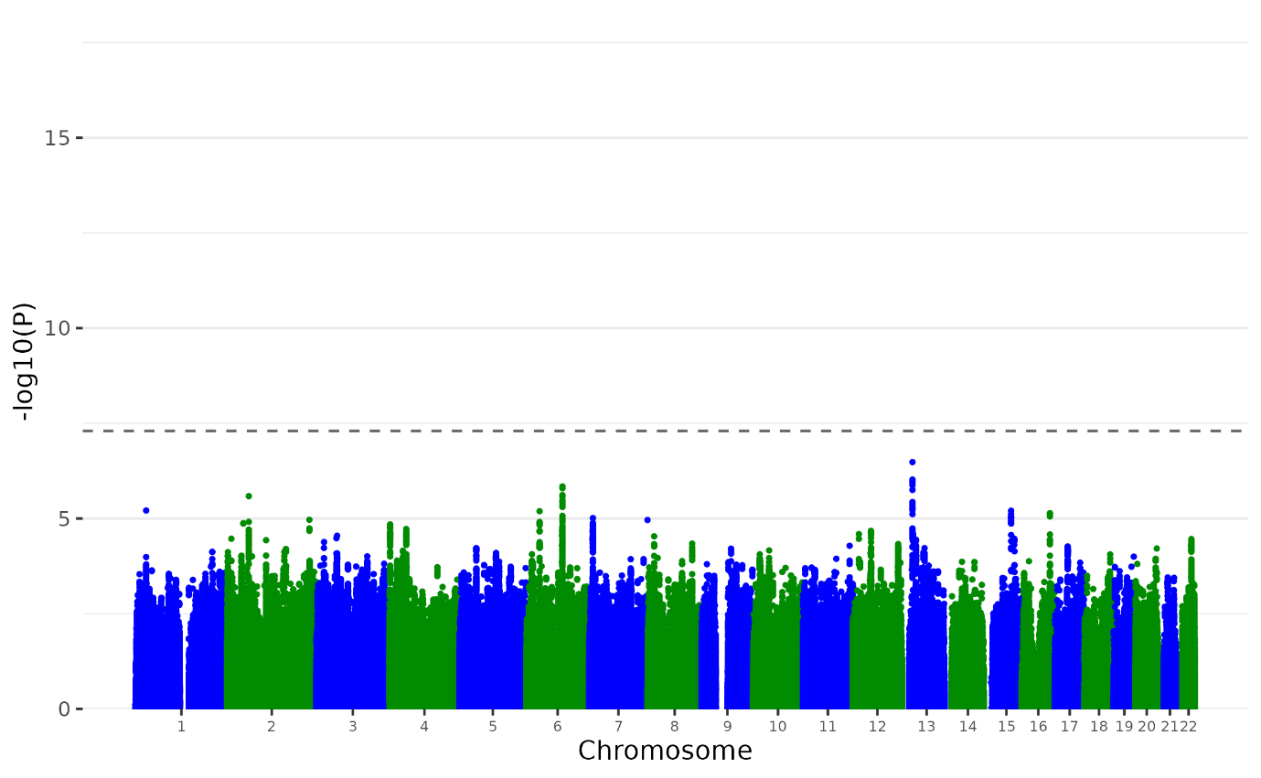

**Supplementary Figure 9. Manhattan plot of the TS Non-p GWAS.** Plot of the -log10(p-value) associated with the Wald test (two-sided) of βp for all SNPs ordered by chromosome and base position. Red diamonds indicate genome-wide significant independent hits (within a 250Kb window and r2 < .1) associations.

SCZ uncorrected for p

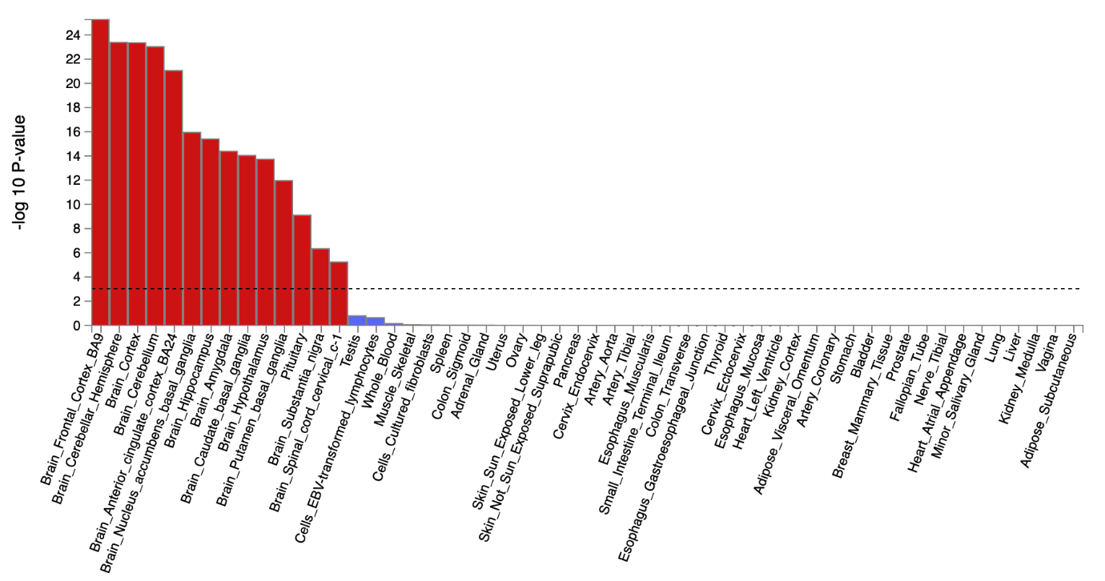

SCZ corrected for p

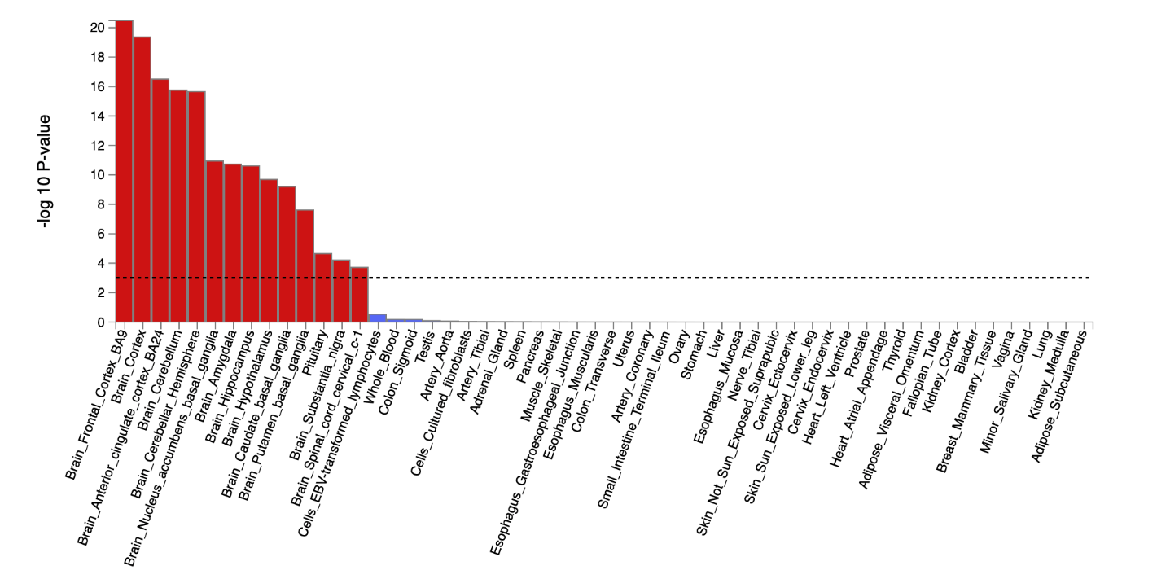

**Supplementary** **Figure 10. The tissue type enrichment results on 53 specific tissue types by GTEx of Schizophrenia uncorrected and corrected for p**

Results (-log10 (one-sided P-value)) from MAGMA gene-property analysis of relationships between tissue specific gene expression profiles (GTEx v.7) and schizophrenia associations before and after correcting for p. The test was performed for average gene-expression per tissue type conditioning on the average expression across all categories. Dotted lines indicate significant results after Bonferroni correction. The full results are available in Supplementary Table 18-21.

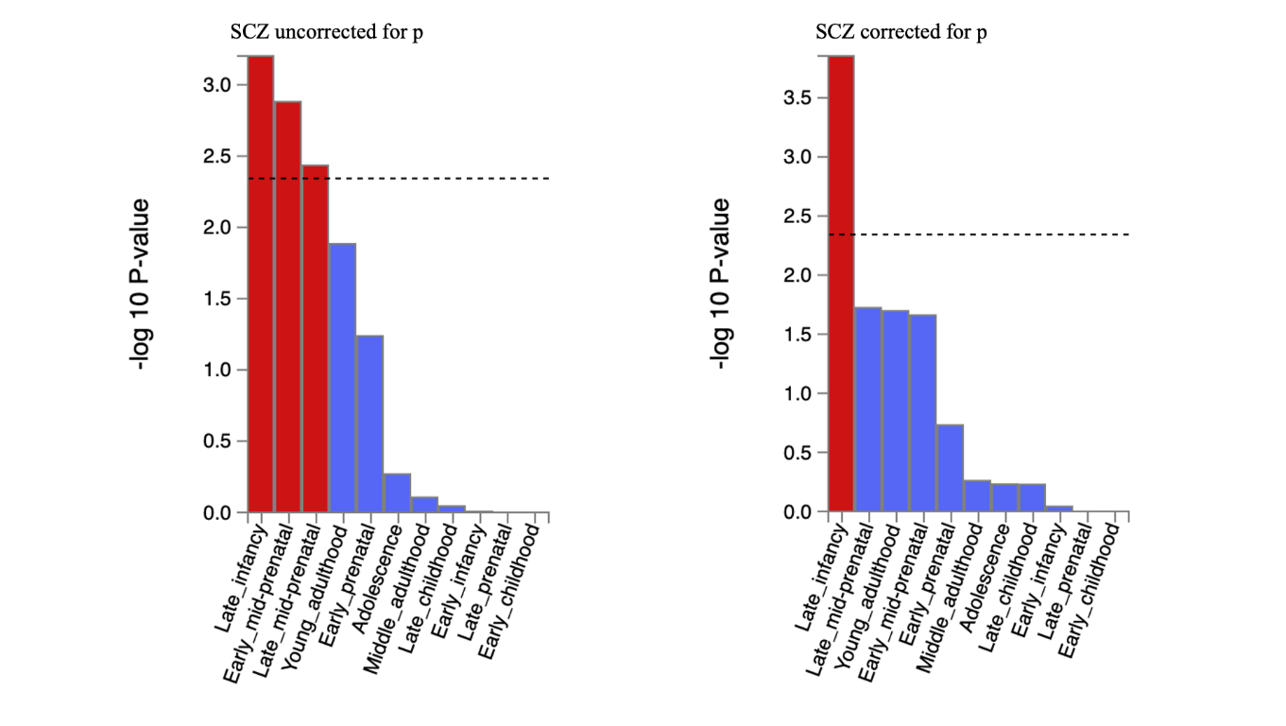

**Supplementary** **Figure 11. The brain sample enrichment results for 11 general brain developmental stages by BrainSpan for schizophrenia uncorrected and corrected for p**

Results (-log10 (one-sided P-value)) from MAGMA gene-property analysis of relationships between gene expression data of developmental brain samples (BrainSpan) and schizophrenia associations before and after correcting for p. The test was performed for average gene-expression per brain sample conditioning on the average expression across all developmental stages. Dotted lines indicate significant results after Bonferroni correction. The full results are available in Supplementary Table 18-21.

BIP uncorrected for p

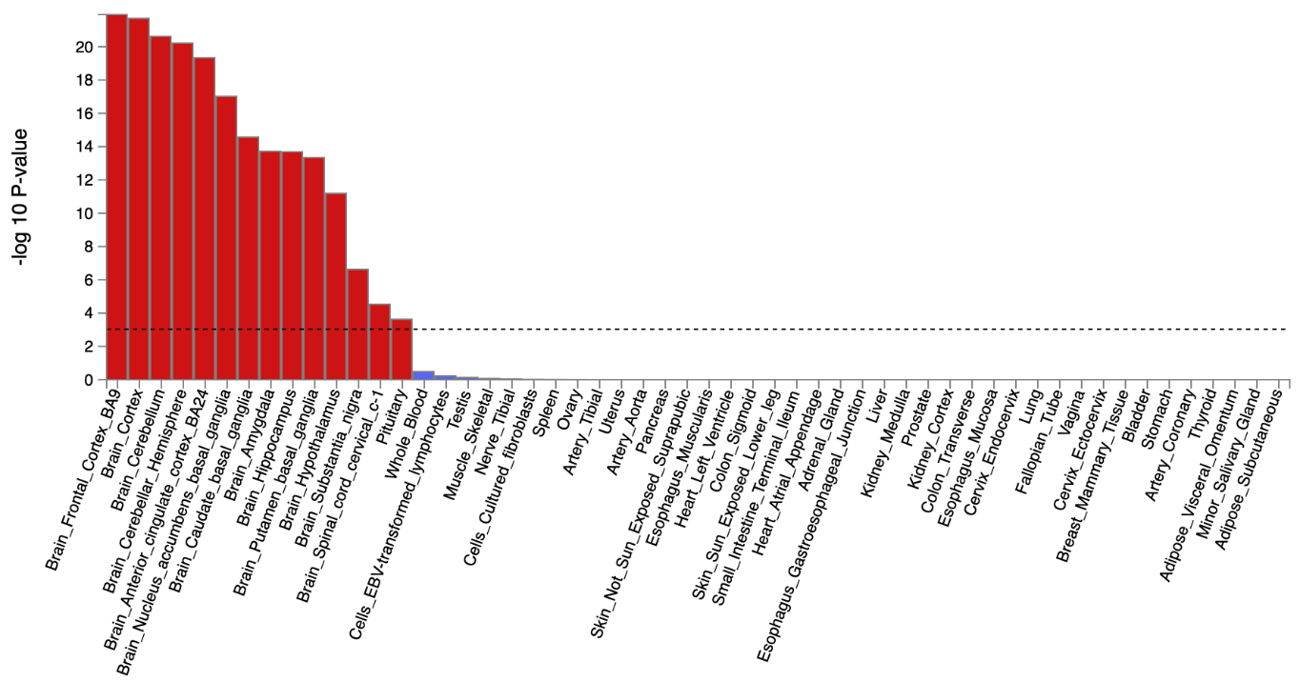

BIP corrected for p

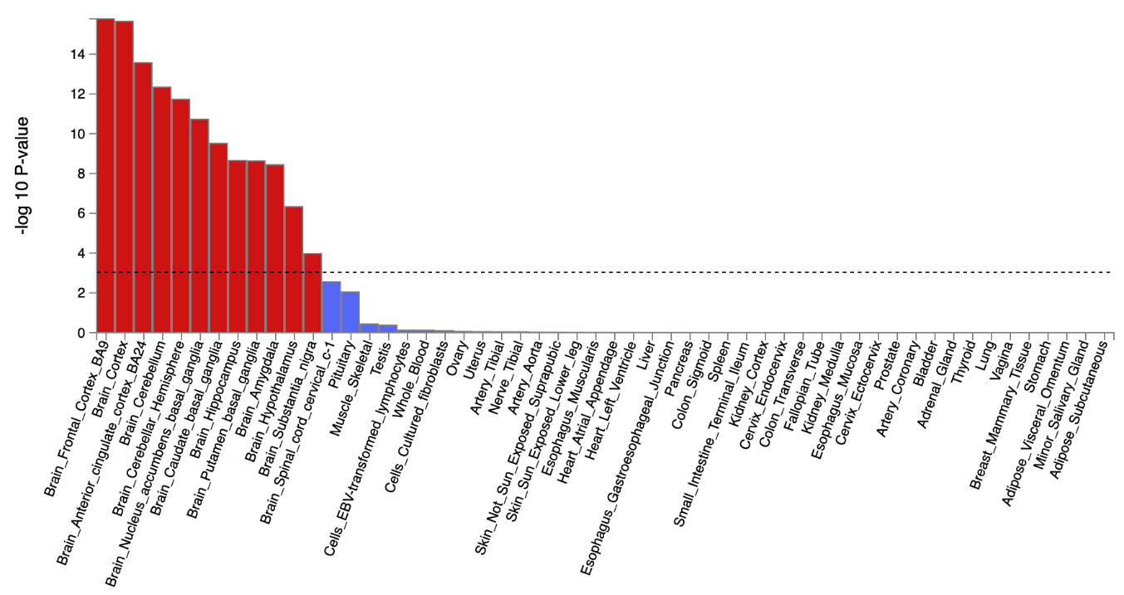

**Supplementary** **Figure 12. The tissue type enrichment results on 53 specific tissue types by GTEx of BIP uncorrected and corrected for p**

Results (-log10 (one-sided P-value)) from MAGMA gene-property analysis of relationships between tissue specific gene expression profiles (GTEx v.7) and Bipolar associations before and after correcting for p. The test was performed for average gene-expression per. tissue type conditioning on the average expression across all categories. Dotted lines indicate significant results after Bonferroni correction. The full results are available in Supplementary Table 22-25.

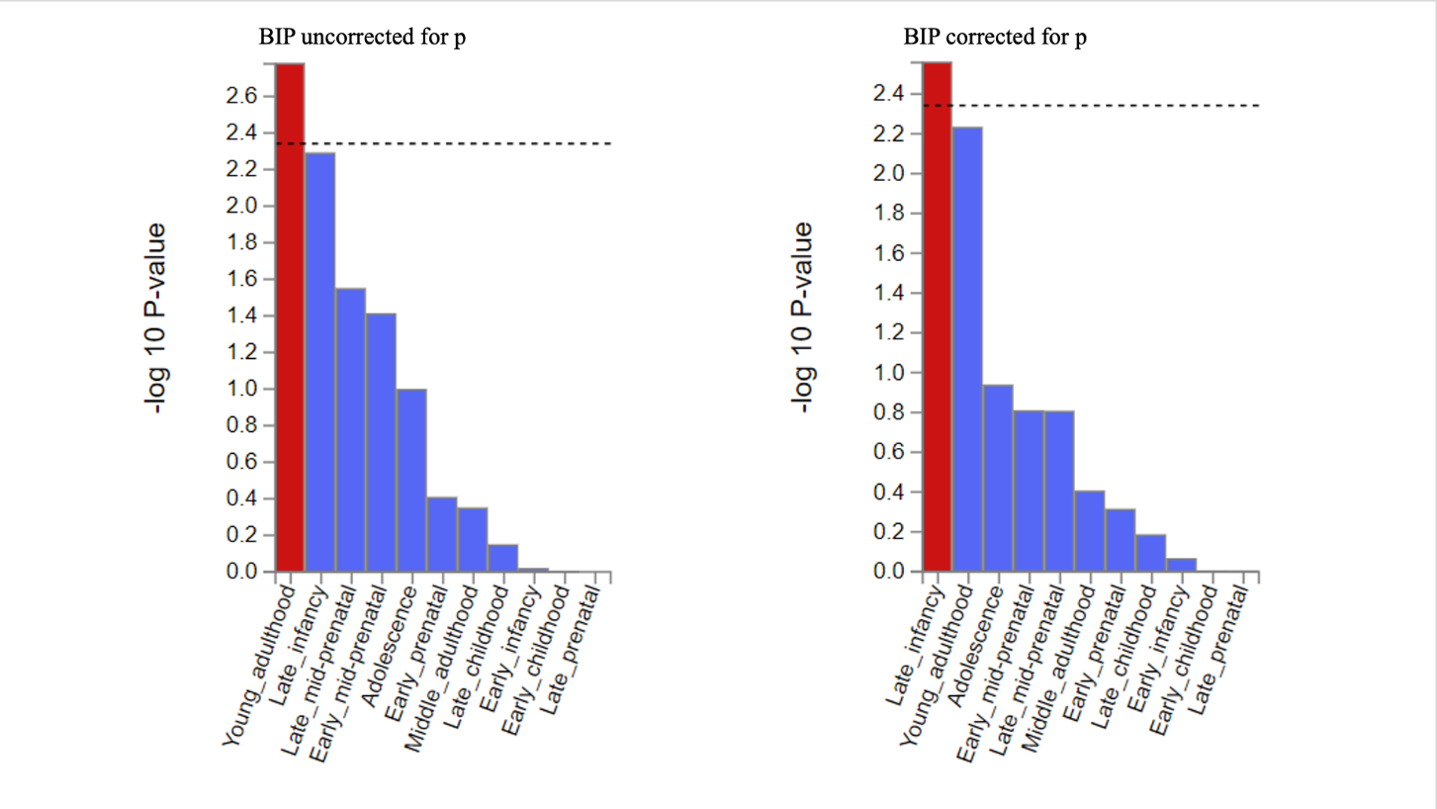

**Supplementary** **Figure 13. The brain sample enrichment results on 11 general brain developmental stages by BrainSpain of Bipolar uncorrected and corrected for p**

Results (-log10 (one-sided P-value)) from MAGMA gene-property analysis of relationships between gene expression data of developmental brain samples (BrainSpan) and Bipolar associations before and after correcting for p. The test was performed for average gene-expression per. brain sample conditioning on the average expression across all developmental stages. Dotted lines indicate significant results after Bonferroni correction. The full results are available in Supplementary Table 22-25.

ADHD uncorrected for p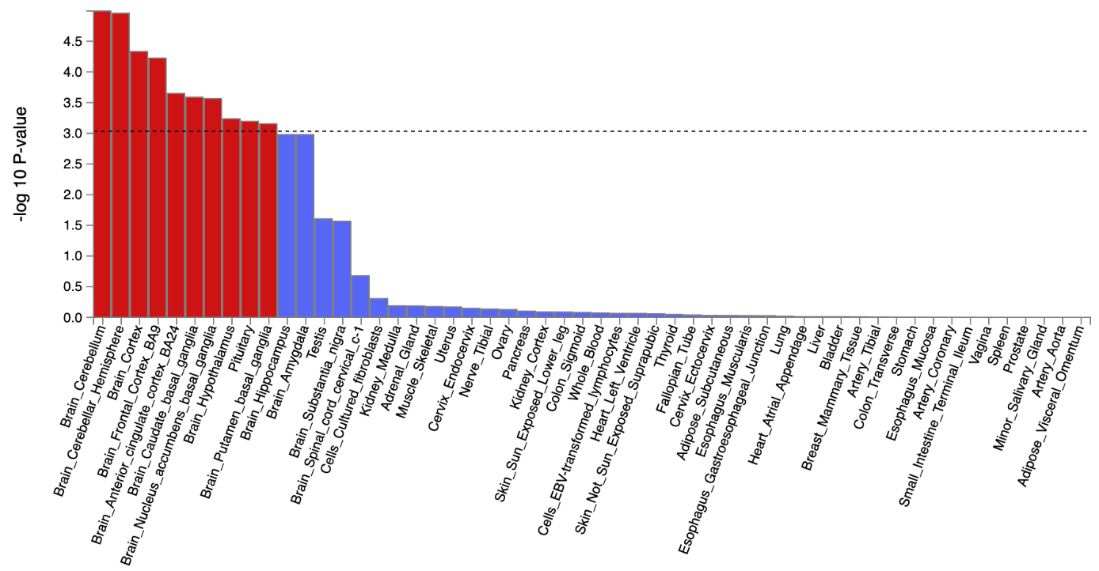ADHD corrected for p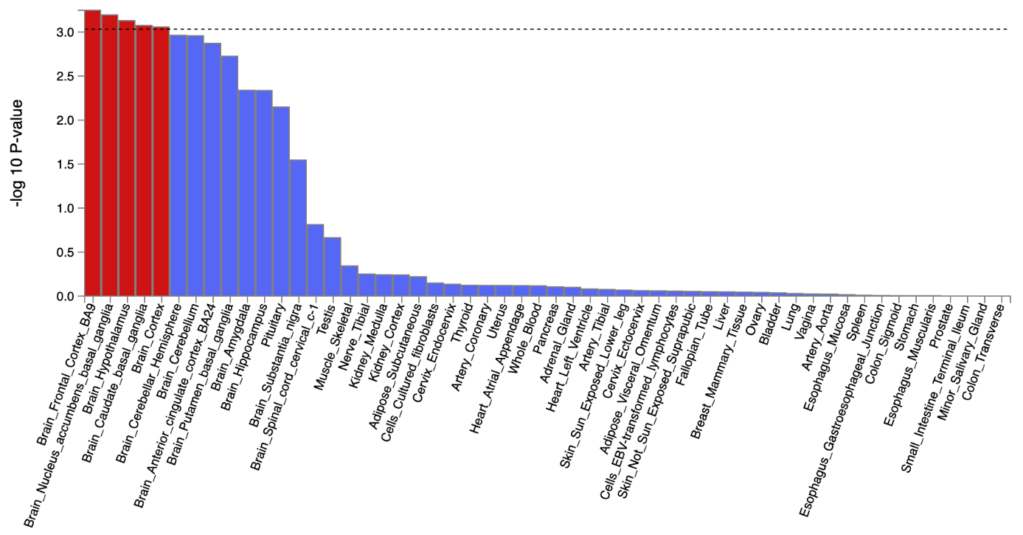**Supplementary** **Figure 14. The tissue type enrichment results on 53 specific tissue types by GTEx of ADHD uncorrected and corrected for p**

Results (-log10 (one-sided P-value)) from MAGMA gene-property analysis of relationships between tissue specific gene expression profiles (GTEx v.7) and ADHD associations before and after correcting for p. The test was performed for average gene-expression per. tissue type conditioning on the average expression across all categories. Dotted lines indicate significant results after Bonferroni correction. The full results are available in Supplementary Table 26-29.

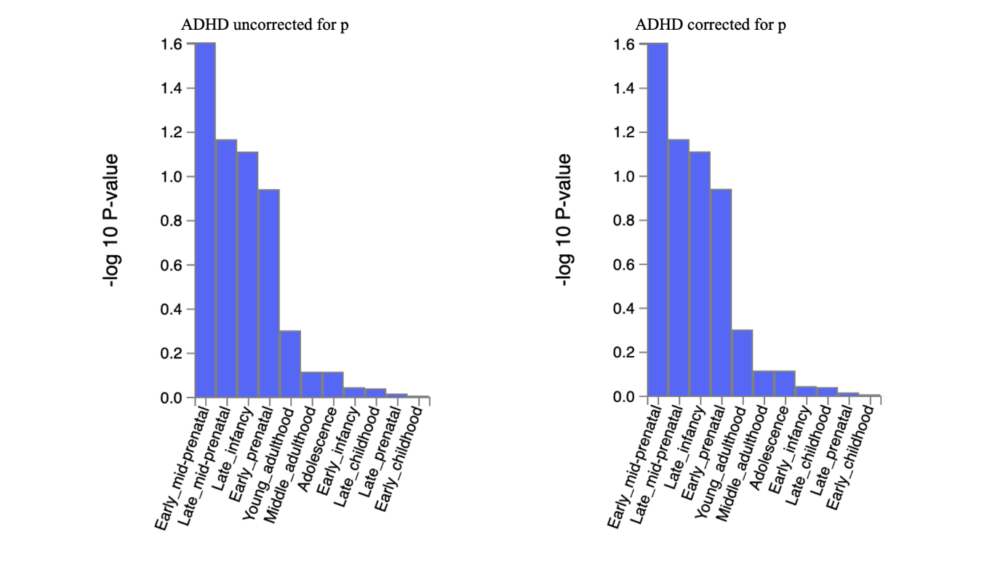

**Supplementary** **Figure 15. The brain sample enrichment results on 11 general brain developmental stages by BrainSpain of ADHD uncorrected and corrected for p**

Results (-log10 (one-sided P-value)) from MAGMA gene-property analysis of relationships between gene expression data of developmental brain samples (BrainSpan) and ADHD associations before and after correcting for p. The test was performed for average gene-expression per. brain sample conditioning on the average expression across all developmental stages. Dotted lines indicate significant results after Bonferroni correction. The full results are available in Supplementary Table 26-29.

AN uncorrected for p

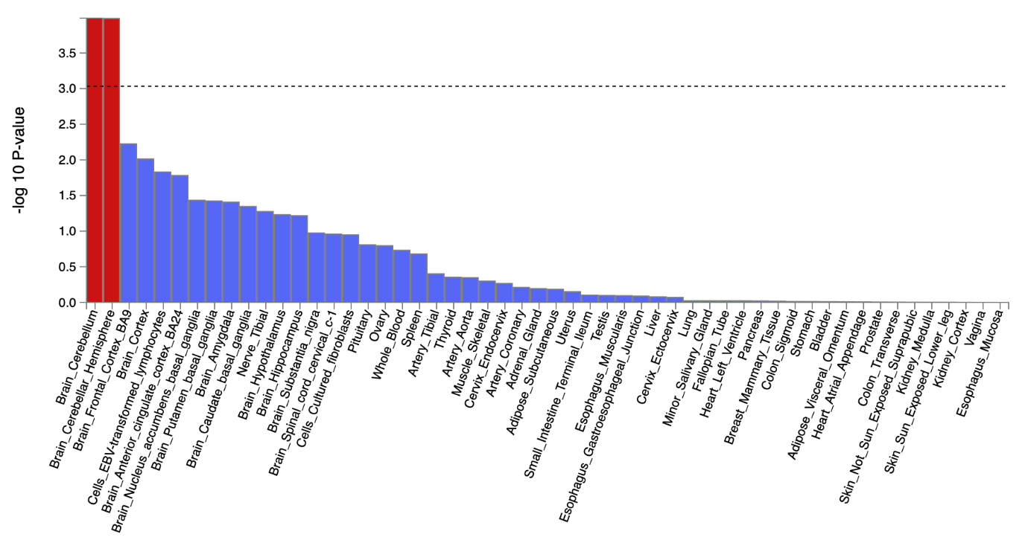

AN corrected for p

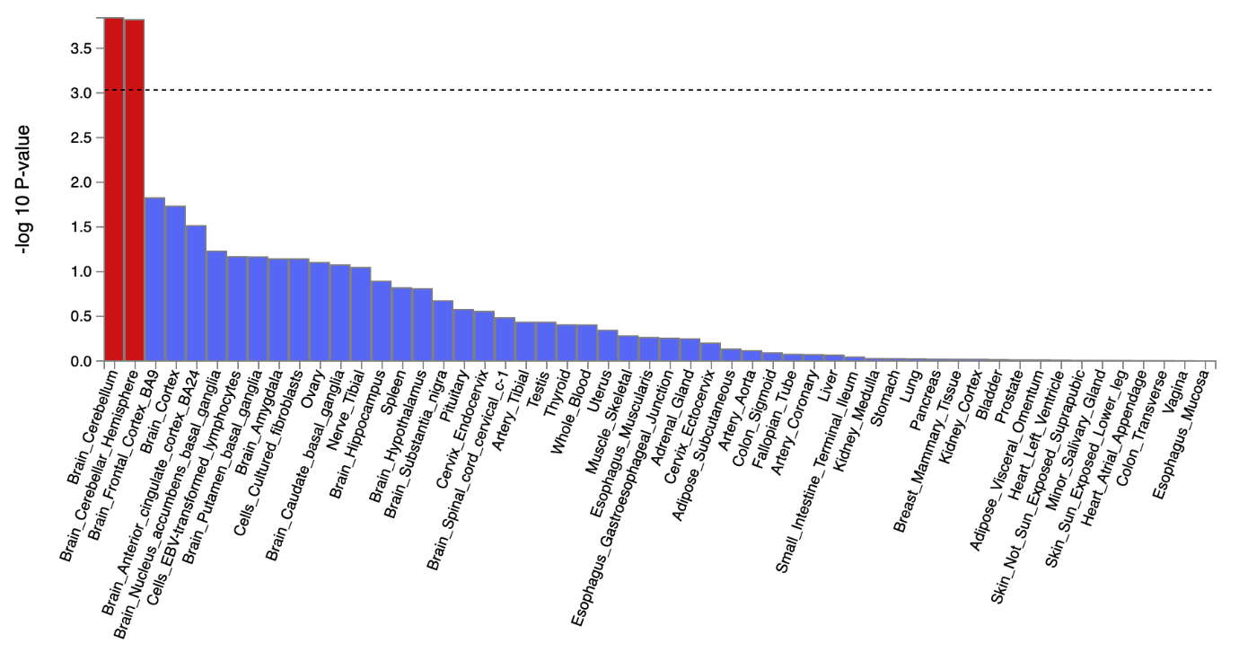

**Supplementary** **Figure 16. The tissue type enrichment results on 53 specific tissue types by GTEx of AN uncorrected and corrected for p**

Results (-log10 (one-sided P-value)) from MAGMA gene-property analysis of relationships between tissue specific gene expression profiles (GTEx v.7) and AN associations before and after correcting for p. The test was performed for average gene-expression per. tissue type conditioning on the average expression across all categories. Dotted lines indicate significant results after Bonferroni correction. The full results are available in Supplementary Table 30-33.

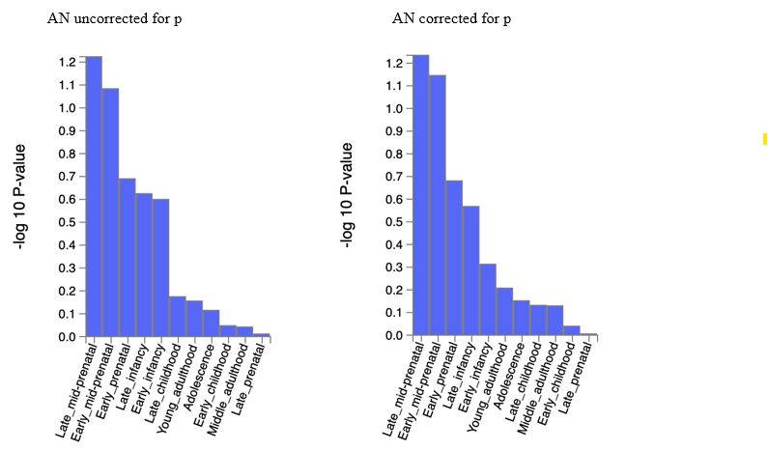

**Supplementary** **Figure 17. The brain sample enrichment results on 11 general brain developmental stages by BrainSpain of AN uncorrected and corrected for p**

Results (-log10 (one-sided P-value)) from MAGMA gene-property analysis of relationships between gene expression data of developmental brain samples (BrainSpan) and AN associations before and after correcting for p. The test was performed for average gene-expression per. brain sample conditioning on the average expression across all developmental stages. The full results are available in Supplementary Table 30-33.

ALCH uncorrected for p

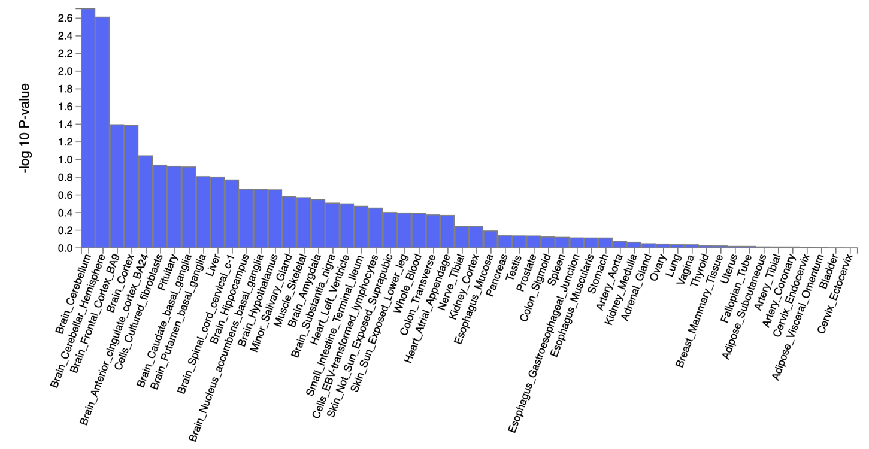

ALCH corrected for p

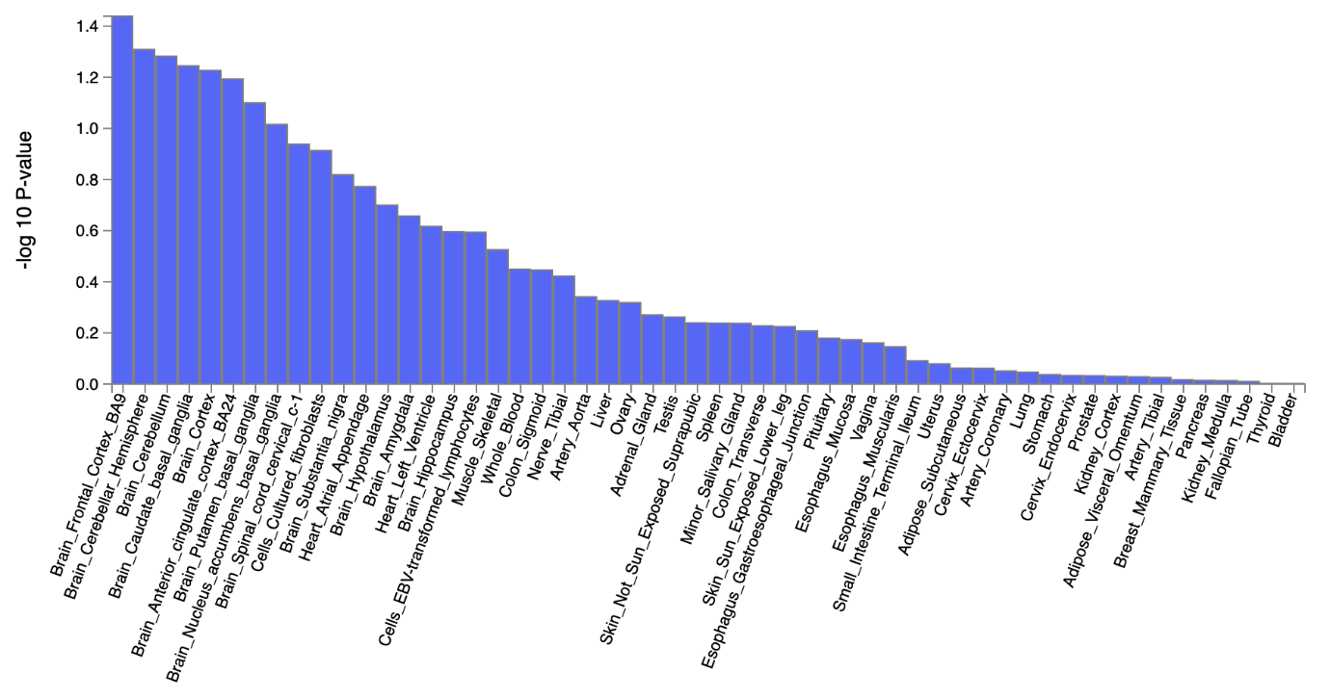

**Supplementary** **Figure 18. The tissue type enrichment results on 53 specific tissue types by GTEx of ALCH uncorrected and corrected for p**

Results (-log10 (one-sided P-value)) from MAGMA gene-property analysis of relationships between tissue specific gene expression profiles (GTEx v.7) and ALCH associations before and after correcting for p. The test was performed for average gene-expression per. tissue type conditioning on the average expression across all categories. The full results are available in Supplementary Table 34-37.

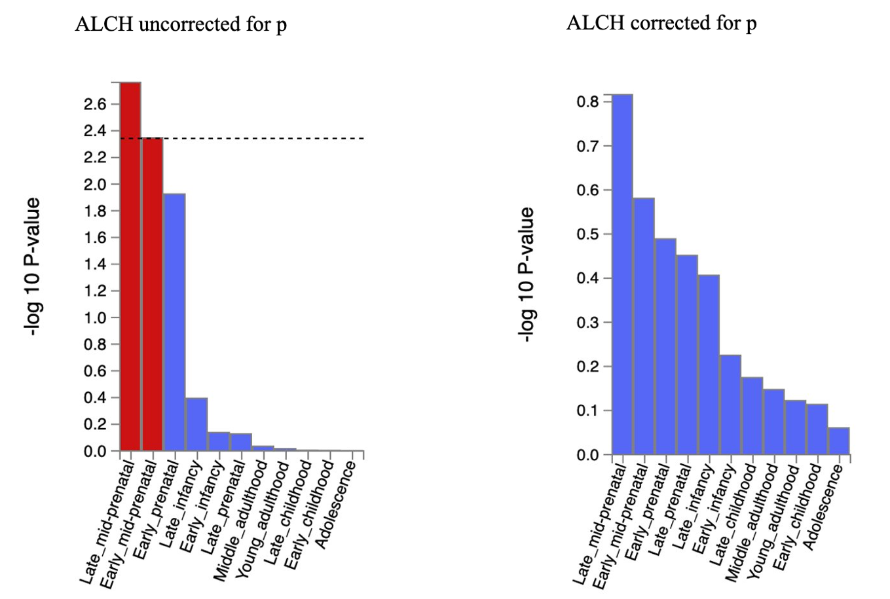

**Supplementary** **Figure 19. The brain sample enrichment results on 11 general brain developmental stages by BrainSpain of ALCH uncorrected and corrected for p**

Results (-log10 (one-sided P-value)) from MAGMA gene-property analysis of relationships between gene expression data of developmental brain samples (BrainSpan) and ALCH associations before and after correcting for p. The test was performed for average gene-expression per. brain sample conditioning on the average expression across all developmental stages. Dotted line indicates significant results after Bonferroni correction. The full results are available in Supplementary Table 34-37.

**Supplementary** **Figure 20. Genetic correlations between psychiatric disorders and health-related traits before and after controlling for p.** The dots represent genetic correlations estimated using LDSC regression. Correlations with psychiatric disorders uncorrected for p are in blue, with psychiatric disorders corrected for p in green. Error bars represent 95% confidence intervals. Red asterisks indicate statistically significant (FDR-corrected *P* < 0.05, two-tailed test) differences in the magnitude of the correlation with disorders uncorrected for p versus disorders corrected for p. Exact *P* values for all associations are reported in Supplementary Table 40.

**Supplementary** **Figure 21. Genetic correlations between 11 major psychiatric disorders and anthropometric traits before and after controlling for p.** The dots represent genetic correlations estimated using LDSC regression. Correlations with psychiatric disorders uncorrected for p are in blue, with psychiatric disorders corrected for p in green. Error bars represent 95% confidence intervals. Red asterisks indicate a statistically significant (FDR-corrected *P* < 0.05, two-tailed test) difference in the magnitude of the correlation with disorders uncorrected for p versus disorders corrected for p. Exact *P* values for all associations are reported in Supplementary Table 40.

**Supplementary** **Figure 22. Genetic correlations between 11 major psychiatric disorders and socio-demographic traits before and after controlling for p.** The dots represent genetic correlations estimated using LDSC regression. Correlations with psychiatric disorders uncorrected for p are in blue, with psychiatric disorders corrected for p in green. Error bars represent 95% confidence intervals. Red asterisks indicate statistically significant (FDR-corrected *P* < 0.05, two-tailed test) differences in the magnitude of the correlation with disorders uncorrected for p versus disorders corrected for p. Exact *P* values for all associations are reported in Supplementary Table 40.

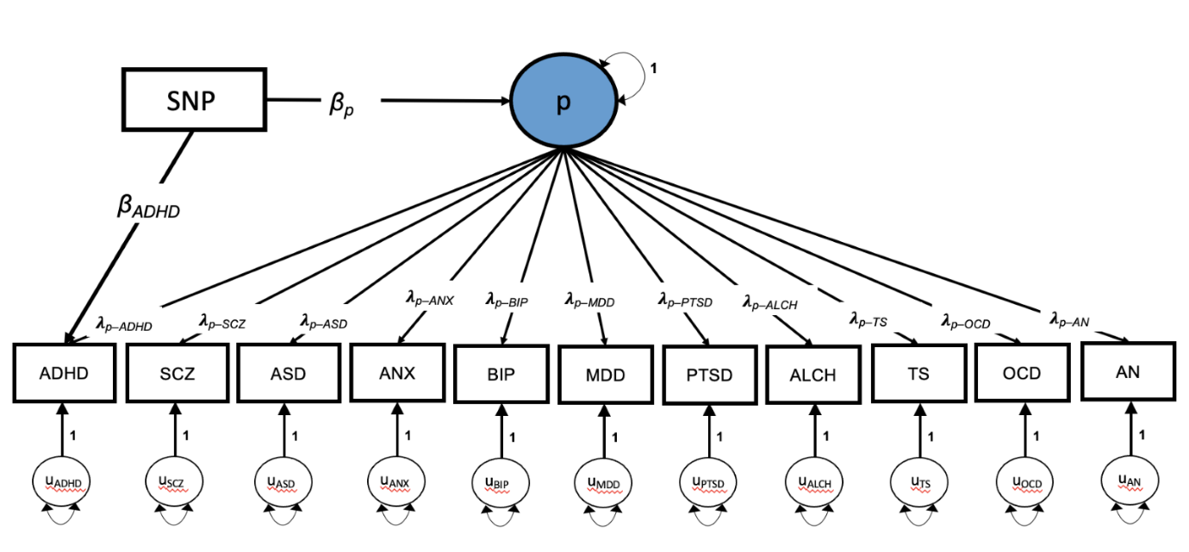

**Supplementary** **Figure 23. Sensitivity analysis- common factor model in Genomic SEM.** This figure shows an alternative way to mode the residual genetic variance in each disorder, after accounting a genomically identified p factor (i.e., non-p). We used a common factor model in Genomic SEM to capture transdiagnostic effects and run GWAS on p and residual variances. We repeated this procedure separately for each disorder to isolate genetic effects beyond p for each disorder at a time. ADHD = attention-deficit hyperactivity disorder; SCZ, schizophrenia; ASD, autism spectrum disorder; ANX, anxiety disorder; BIP, bipolar disorder; MDD, major depressive disorder; PTSD, post-traumatic stress disorder; ALCH, problematic alcohol use; TS, Tourette syndrome; OCD, obsessive-compulsive disorder; AN, anorexia nervosa; p, general psychopathology factor. λ= freely estimated factor loadings that are equivalent to regression weights. Β= regression effects of ADHD and p on the SNP.

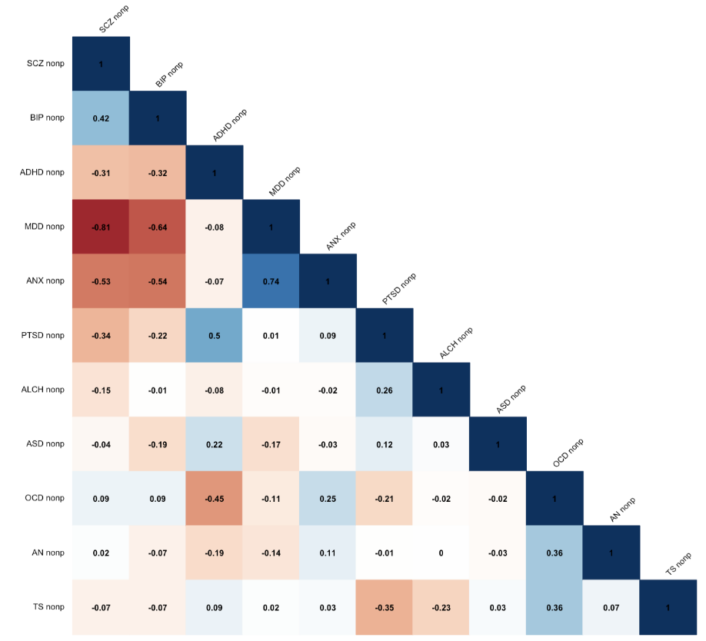

**Supplementary** **Figure 24. Genetic correlations between psychiatric disorders after correcting for p from sensitivity analysis.** Genetic correlations between the 11 psychiatric disorders obtained from the common factor model (Supplementary Figure 23) in Genomic SEM.

**Supplementary References:**

1. Grotzinger, A.D. *et al.* Genomic structural equation modelling provides insights into the multivariate genetic architecture of complex traits. *Nat Hum Behav* **3**, 513-525 (2019).

2. Grotzinger, A.D., Fuente, J., Prive, F., Nivard, M.G. & Tucker-Drob, E.M. Pervasive Downward Bias in Estimates of Liability-Scale Heritability in Genome-wide Association Study Meta-analysis: A Simple Solution. *Biol Psychiatry* **93**, 29-36 (2023).

3. Demange, P.A. *et al.* Investigating the genetic architecture of noncognitive skills using GWAS-by-subtraction. *Nat Genet* **53**, 35-44 (2021).

4. Mallard, T.T. *et al.* Multivariate GWAS of psychiatric disorders and their cardinal symptoms reveal two dimensions of cross-cutting genetic liabilities. *Cell Genomics* **2**, 100140 (2022).

5. Workalemahu, T. *et al.* Genetic variations and risk of placental abruption: A genome-wide association study and meta-analysis of genome-wide association studies. *Placenta* **66**, 8-16 (2018).

6. Sakaue, S. *et al.* A cross-population atlas of genetic associations for 220 human phenotypes. *Nat Genet* **53**, 1415-1424 (2021).

7. Sha, Z. *et al.* The overlapping genetic architecture of psychiatric disorders and cortical brain structure. *bioRxiv* (2023).

8. Hindley, G. *et al.* Multivariate genetic analysis of personality and cognitive traits reveals abundant pleiotropy. *Nat Hum Behav* **7**, 1584-1600 (2023).

9. Lee, J.J. *et al.* Gene discovery and polygenic prediction from a genome-wide association study of educational attainment in 1.1 million individuals. *Nat Genet* **50**, 1112-1121 (2018).

10. Howard, D.M. *et al.* Genome-wide meta-analysis of depression identifies 102 independent variants and highlights the importance of the prefrontal brain regions. *Nat Neurosci* **22**, 343-352 (2019).

11. Adams, D.M., Reay, W.R. & Cairns, M.J. Multiomic prioritisation of risk genes for anorexia nervosa. *Psychol Med* **53**, 1-9 (2023).

12. Tsetsos, F. *et al.* Meta-Analysis of Tourette Syndrome and Attention Deficit Hyperactivity Disorder Provides Support for a Shared Genetic Basis. *Front Neurosci* **10**, 340 (2016).

13. Taylor, D.L. *et al.* Interactions between genetic variation and cellular environment in skeletal muscle gene expression. *PLoS One* **13**, e0195788 (2018).

14. Watanabe, K., Taskesen, E., van Bochoven, A. & Posthuma, D. Functional mapping and annotation of genetic associations with FUMA. *Nat Commun* **8**, 1826 (2017).

15. Watanabe, K., Umicevic Mirkov, M., de Leeuw, C.A., van den Heuvel, M.P. & Posthuma, D. Genetic mapping of cell type specificity for complex traits. *Nat Commun* **10**, 3222 (2019).

16. Watson, H.J. *et al.* Genome-wide association study identifies eight risk loci and implicates metabo-psychiatric origins for anorexia nervosa. *Nat Genet* **51**, 1207-1214 (2019).

17. Christakoudi, S., Evangelou, E., Riboli, E. & Tsilidis, K.K. GWAS of allometric body-shape indices in UK Biobank identifies loci suggesting associations with morphogenesis, organogenesis, adrenal cell renewal and cancer. *Sci Rep* **11**, 10688 (2021).

18. Zhu, Z. *et al.* Shared genetic and experimental links between obesity-related traits and asthma subtypes in UK Biobank. *J Allergy Clin Immunol* **145**, 537-549 (2020).

19. Hill, W.D. *et al.* A combined analysis of genetically correlated traits identifies 187 loci and a role for neurogenesis and myelination in intelligence. *Mol Psychiatry* **24**, 169-181 (2019).

20. Schumann, G. *et al.* KLB is associated with alcohol drinking, and its gene product beta-Klotho is necessary for FGF21 regulation of alcohol preference. *Proc Natl Acad Sci U S A* **113**, 14372-14377 (2016).